**STEM Middle School 2024 Summer Programs**

**STEM Summer Programs are mandatory instructional components for students in grades 6-8 in the AACPS STEM Middle School Magnet Program.** These programs are grade level specific and designed to introduce students to unique concepts and content that they will utilize in middle school and throughout their high school career.

Diving into targeted STEM topics allows students to begin building their own foundation of skill sets prior to the beginning of the school year. These foundations then become tools that students have in their toolboxes which can be used to solve challenges and create opportunities throughout their STEM journey and in the real world. In addition, STEM Summer Programs allow us to introduce students to the STEM Values and empower our students to apply these values to impact the lives of others in an authentic way.

**STEM Summer Programs 2024**

**Description STEP up to STEM 6:**

**Ecology- Environmental Literacy**

Students examine the concept of ecology and the importance and relevance of natural science in their lives. The cohort will additionally be introduced to the AACPS STEM Values, building relationships, communication, game playing and outside STEM fieldwork. This program includes a mandatory overnight camp experience at the Maryland Science Center.

**Description STEP up to STEM 7:**

**Crime Busters- Forensic Science**

Students discover the distinct types of forensics, DNA structures, chromatography and the scientific process involved in solving a crime. This program includes an off-campus field experience in forensic research and investigation. This program also includes time for practicing communication and collaboration skills.

**Description STEP up to STEM 8:**

**Prosthetics and Changemaking- Engineering & Health Sciences**

Students engage in the engineering design process and design thinking to construct prosthetic protypes for different animal species while making connections to becoming a Changemaker. This program includes an off-campus field experience in building confidence, teamwork, communication, and trust.

**Click the link below to register your student for a STEM summer program**. Make sure you are registering for the STEM summer program related to the STEM Middle School Magnet Program, Magnet Program school, and grade level your student will be enrolled in during the Fall of 2024.

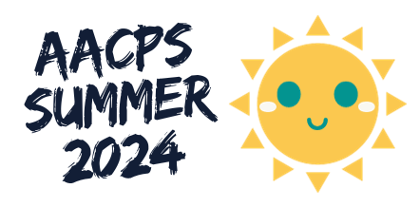[**https://www.aacps.org/summer**](https://www.aacps.org/summer)